**UDP Emulator User Guide**

This document contains instructions on how to use the LabVIEW UDP Emulator deployable VI including loading in ASCII human readable txt or csv files, setting up the UDP IP streaming settings and general use.

1. Installation and Startup

From the National Instruments (NI) website download the most recent LabVIEW runtime engine (32 bit, unless you are having issues in which case try the 64 bit version).

You will need to create an NI account; however, you shouldn’t have to enter a license key.

If you are having trouble downloading the runtime engine, use the local installer located in the ‘LabVIEW runtime installer’ directory. However, this is not ideal and may cause issues or instabilities if the local runtime engine installer version is significantly outdated.

Once you have worked through the installation process you should be ready to run the executable.

1. Loading in a File

Files which need to be streamed should be copied into the ‘emulator data’ sub directory, don’t place them in a sub directory within this folder.

These files should either be txt or csv and ideally use a carriage return (newline) to separate each data line (the ability to change this may be present in later iterations).

The delimiter does not matter but will affect whether your UDP listening code can process the data correctly so it should be considered.

Ideally files should not have headers or footers, these shouldn’t cause issues if they are formatted in the same way as each data line, i.e., they are separated by a carriage return. However, they will also be streamed as a UDP and may cause issues with software listening to and using the UDP string.

1. Overview and General use

Run the executable vi ‘UDP Emulator’ by double clicking on it, it should start automatically. If you see the message below select…

*Image here*

The table below describes what each of the inputs and outputs on the LabVIEW interface show/ control.

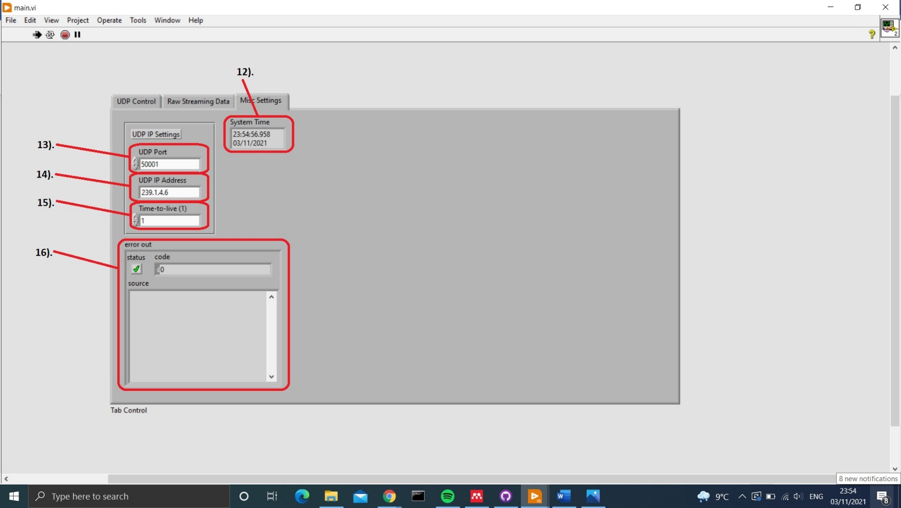

*Table 1: Tabulated explanations of input/outputs on the executable front panel.*

|  |  |  |  |
| --- | --- | --- | --- |
| Number | Name | Input data type | Description |
| 1 | Data Files Available for Streaming | String (file names cannot be manually overridden) | Lists files in the ‘emulator data’ sub directory available to be loaded and streamed. Select one of these before proceeding any further |
| 2 | Data Frequency / Hz | Integer | Frequency at which the ASCII data has been logged. This can be approximate. If it is out slightly points may be skipped/ extra points included but this shouldn’t matter. Files acquired at a different frequency can be used in tandem |
| 3 | Add File to Stream | Boolean | Loads a file into the emulator buffer ready to be streamed as a UDP. The file loaded depends on what is selected in input 1). and will be shown in output 9). |
| 4 | Remove File from Stream | Boolean | Removes a loaded file from the emulator buffer. The file removed depends on what is selected in input 1). |
| 5 | UDP Stream On | Boolean | Starts streaming the UDP data on the IP settings provided |
| 6 | Skip Points (All Files) | Boolean | Skips several data lines in all the loaded UDP files depending on what has been entered for input 7). |
| 7 | Number of Points to Skip | Integer | The number of data lines to be skipped upon activating Boolean 6). |
| 8 | STOP PGRM | Boolean | Stops the LabVIEW code and closes all ports/ streams safely. |
| 9 | Files Being Streamed on UDP |  | An array of the names of files which have been loaded |
| 10 | Remaining Data Lines |  | An array of the number of remaining data lines for files which have been loaded, corrected for frequency |
| 11 | Raw Data Array |  | The instantaneous raw data line for each file which is currently being sent to the UDP port. If the UDP stream is not on, this will be static. |
| 12 | System Time |  | System time, only used to confirm if the executable has frozen |
| 13 | UDP Port |  | The port which the UDP data should be streamed on. The range of values are dependent on you setup |
| 14 | UDP IP Address |  | The IP address which UDP data should be forwarded too. |
| 15 | Time-to-live (1) |  | Time-to-live determines how the routers on the network should handle the UDP data. The current settings allow them to forward any packets they receive and generally this should not be changed. |
| 16 | Error Out |  | Displays error messages which may be causing the executable to fail. |